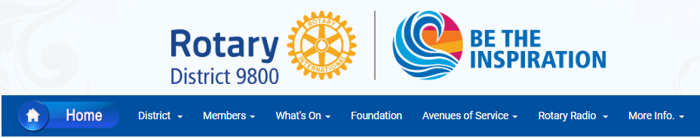

INTERESTED IN HAVING YOUR EVENT LISTED ON THE DISTRICT WEBSITE?
Please make sure that the information is sent at least 30 days before the Event

CLUBS USING CLUBRUNNER
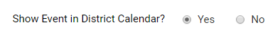
Enter Event Details on you Club Website and select
Please only include Special Events in this category and NOT normal Club Events
OTHER DISTRICT 9800 CLUBS
Please complete the following:
EVENT NAME
START DATE & TIME END DATE AND TIME
DESCRIPTION OF EVENT

Please include a high-quality pdf or picture as an attachment
CLUB NAME CONTACT MOBILE
EMAIL
EVENT LOCATION ADDRESS 1
ADRESS 2
CITY POSTCODE

PLEASE NOTE: Please ensure that all details are included
Every attempt will be made to include your Event in the What’s On section

SEND THESE DETAILS ATTACHMENTS TO events@rotarydistrict9800.org.au

